The Outputs of the Face-recognition-Attendance system: -

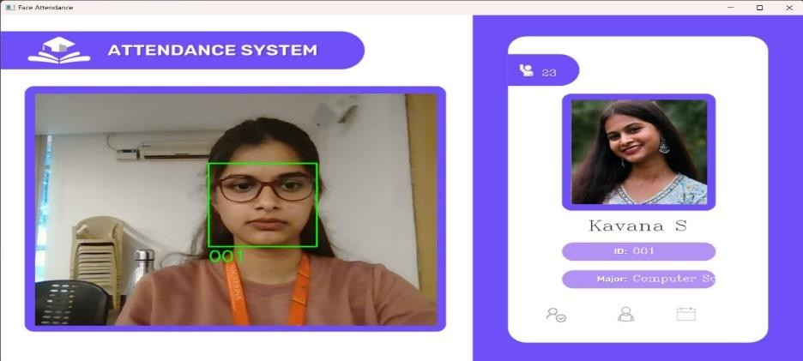

A student comes and scan their faces in the web-camera or the high resolution cameras, if the student’s face data is stored in the database(firebase) then it recognises It will display the attendance with name and USN and the branch and show the attendance mark it

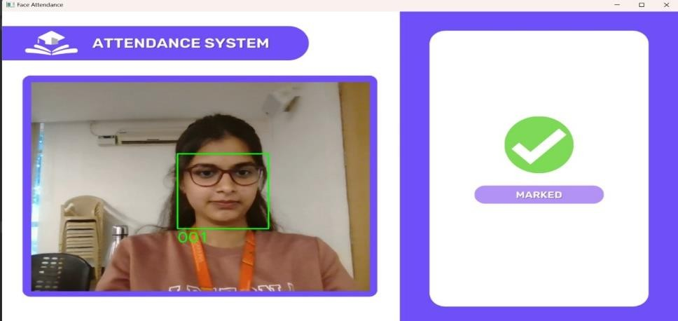

The attendance is marked and updated in the real time database

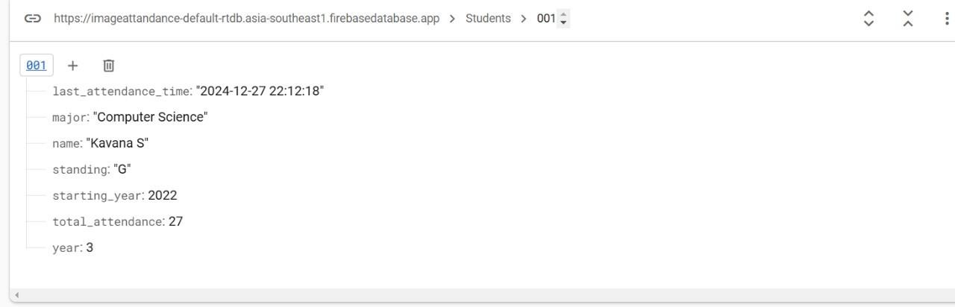

The student data should be stored in the database with the student name, and the total attendance, major, starting_year and the date and time